## Assignment-2

## Produce a comparative infographic of TDD, BDD, and FDD methodologies. Illustrate their unique approaches, benefits, and suitability for different software development contexts. Use visuals to enhance understanding.

## Test-Driven Development (TDD):

Approach: Write tests before writing code.

## Benefits:

* Ensures code functionality.
* Provides a safety net for refactoring.
* Promotes modular design.

## Suitable for:

* Agile environments.
* Projects with evolving requirements.
* Teams emphasizing code quality.

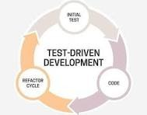

## Behaviour-Driven Development (BDD):

Approach: Focuses on behaviour rather than implementation details.

## Benefits:

* Encourages collaboration between developers, QA, and non-technical stakeholders.
* Improves communication through shared understanding of behaviour.
* Helps in identifying edge cases and user scenarios early.

## Suitable for:

* Complex projects with multiple stakeholders.
* Projects requiring clear documentation.
* Agile teams striving for user-centric development.

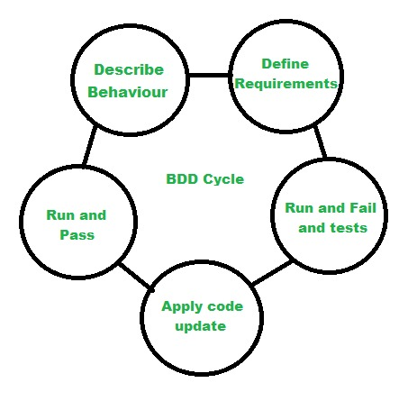

## Feature-Driven Development (FDD):

Approach: Breaks down development into feature sets.

## Benefits:

* Provides a structured approach to development.
* Emphasizes incremental delivery.
* Facilitates clear progress tracking.

## Suitable for:

* Large-scale projects.
* Projects with defined requirements.
* Teams with experienced developers.

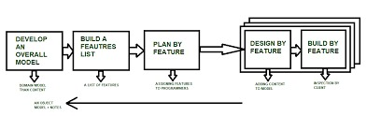

Conclusion:

Encourage readers to choose the methodology that best fits their project requirements and team dynamics.

This infographic provides a concise overview of TDD, BDD, and FDD, highlighting their unique approaches, benefits, and suitability for different software development contexts. Visual elements help enhance understanding and make the information more engaging for readers.